

The Hut 2025-2026

Spring Newsletter

Welcome to the Spring Term at Birchwood Avenue Primary School. Our focus will be on supporting each child’s unique strengths and needs, with a range of engaging activities designed to encourage confidence, independence, and joyful learning. From sensory experiences to creative projects, we will make the most of this special time of year. Our learning superpower this half term will be ‘Empathy’ where children will begin to understand and share the thoughts and feelings of others. We feel as a school that our values underpin our learning behaviour, and this is reflected in how we treat other people.

Phonics
We will continue to teach phonics every day in our class. The children are assessed regularly to ensure that they receive one-to-one support from an adult. This allows for high quality teaching and ensures that personalised learning can take place. At Birchwood Avenue, we use a scheme called Read Write Inc. In phonics, each child will work one-to-one with an adult daily. They will learn new sounds, practice letter formation, and blend sounds to read and spell words. Phonics knowledge will help children decode words and read accurately.
They will continue to develop their reading skills, using these sounds to read books fluently and with confidence.

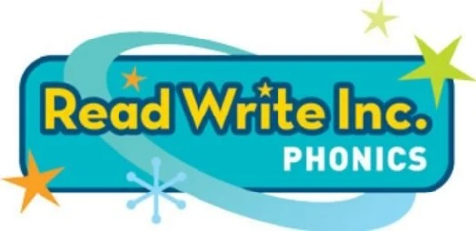

Reading

Reading is an important part of our daily learning, and children in our class enjoy listening to stories. Children read to an adult every day, which helps to build vocabulary and exposes children to new words and phrases. It helps children to understand sentence structure and improves listening skills, attention and prompts a love of stories. A book will be sent home and we ask that you read daily with your child and sign the reading record. This book will help to develop fluency when reading whilst using their phonic knowledge and word blending skills. Alongside this book, a library book will come home to promote a love of reading.
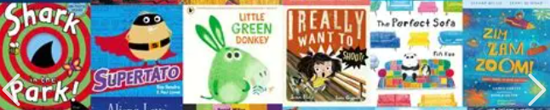

Writing
In our class, we use Drawing Club, a fun and imaginative approach to writing that helps your child develop early writing, storytelling, and language skills. In each session, we read a book linked to our themed learning. We learn ambitious vocabulary we might find in the story and revisit it daily. Children are given the opportunity to talk and explain their ideas, develop their imagination, begin writing independently, and explore new words and language linked to the stories. The children will gradually work towards writing a sentence independently, ensuring that the correct punctuation is in place. Additional opportunities for writing can be found throughout the provision.

Maths
This term, we will be focusing on helping the children to develop a deep understanding of numbers to 10. This means they are not just counting, but really understanding what each number is made of. The children will learn to understand numbers to 10, including how each number can be composed and partitioned (for example, knowing that 5 can be made from 2 and 3, or 4 and 1). They will continue to learn to subitise quantities up to 5 (recognising how many objects there are without needing to count them). Children will be encouraged to automatically recall number bonds to 5, including subtraction facts (e.g. 5 − 2 = 3). They will begin to recall some number bonds to 10, including double facts. We use songs, stories, tens frames, practical resources and games to help make this learning secure and enjoyable. Alongside number, the children will be exploring patterns within numbers and how numbers relate to each other. Children will learn to verbally count beyond 20, noticing the repeating patterns in the counting system. They will learn to compare quantities up to 10 in different contexts, using language such as greater than, less than and the same as. The children will also learn to explore patterns in numbers up to 10, recognising even and odd numbers, double facts and how amounts can be shared equally. These skills help children to reason, explain their thinking and build strong foundations for future maths learning.
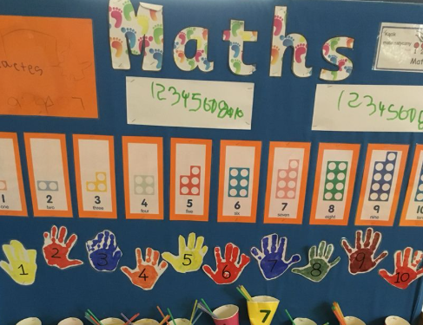

PE
On Thursdays, we will teach PE to the children. This term, the children will be learning about attack and defence games and how exercise affects our bodies. We incorporate music into our PE lessons to encourage participation and make it enjoyable.

Science
In Science, children will be learning about what floats and sinks in water. They will adapt objects to see whether they float or sink. This aims to develop their understanding of some important processes and changes in the natural world around them, including changing states of matter.

Themed learning
During Spring Term 1, our themed learning will be based around ‘Traditional Tales’. Learning provision will be provided which sparks interest and curiosity around this theme whilst linking with their writing in Drawing Club. The children will be able to visit ‘The Gingerbread Man’s Bakery’ and ‘Jack and the Beanstalk’s Castle’ amongst other exciting opportunities. During the second half of the term, we will be learning about nature and growing and will develop our outside garden into a growing area for a variety of plants and vegetables.

Music
Children will explore core musical skills, will explore different types of musical instruments and learn through fun games.

PSHE
During our PSHE lessons, the children will have the opportunity to think about their ‘Dreams and Goals’ and set themselves challenging to overcome.
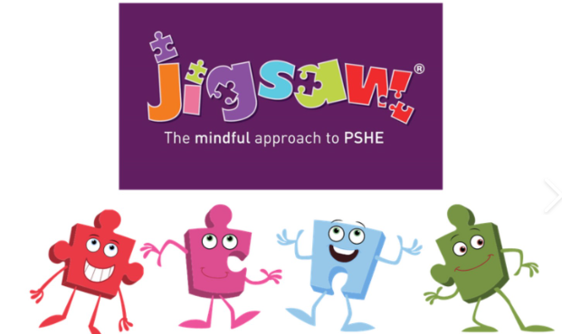

Although our learning is child-led, the curriculum is planned carefully to ensure that progression towards the Early Learning Goals and incudes a strong focus on developing communication and language skills. The children are provided with a wide range of stimulating, purposeful and exciting learning opportunities to support this. With your continuing support, the sharing of information and maintaining open communications, we can support your child’s happiness, confidence and success during this important year. Please do not hesitate to speak with us.

Mrs Markus, Miss Williams, Mr Hynes

