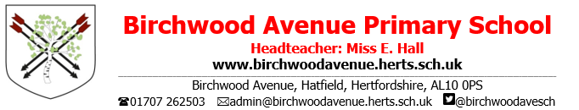
Year 6 Spring Newsletter

Welcome back for the Spring term. We are looking forward to continuing our hard work that we began last term. Our Learning Superpower this half term will be ‘Empathy’, where we will celebrate showing empathy towards one another and being considerate of each other’s feelings. We feel as a school that our values underpin our learning behaviour, and this is reflected in our work.

PE
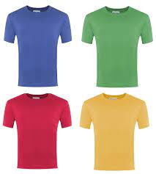
Our PE days this term are Tuesday and Friday. Children should wear full uniform to school and bring their PE kits with them. PE kits should include a t-shirt that matches their house colour, trainers, and shorts or jogging bottoms.
We will start the Spring term by developing skills in gymnastics and football. After the half term, we will focus on tennis.

English
In English, we will be starting the term looking at the text War Horse by Michael Morpurgo. We will look at a range of genres, including a persuasive text in the form of propaganda. We will then focus on non-fiction, producing a biography about Walter Tull, who was a pioneering English professional footballer and the first Black British Army Officer to command white troops in World War I. We will then explore some emotive narrative writing based on the short film ‘The Piano’.

Reading
Please continue to support your child, to encourage a love for reading. Your child will bring home a book from the classroom reading corner each day, linked to their reading level. We expect them to read out loud to an adult for at least 10 minutes each evening. It is really important that you are asking questions about what the children are reading to ensure that they are comprehending the text. Please support this process by writing a short comment and signing in your child’s reading record. A year 6 reader should be able to read aloud with fluency and expression, using punctuation to aide understanding and with the ability to talk with confidence about what they have read.

Maths
This term will see some new topics that have not yet been explored in previous year groups. We will begin by learning about the order of operations and learning the formal method for long division. The rest of the half term will cover area, perimeter, angles, reflection and translation, and multiplying fractions. All of our learning will focus on both varied fluency and reasoning and problem solving.

Science
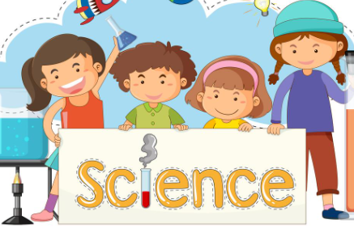 | This half term, we will be learning about electricity. We will recap some key concepts for electricity, before moving on to how we can change circuits to have a required outcome. During the second half term, we will focus on classification of species. Throughout both units of work, we will be combining theory and practical work and learning through scientific enquiry.

History
During the first half term, our history topic is World War II. We will answer the question ‘What was the impact of World War II on the people of Britain?’ through exploring a range of sources. We will learn about: the events that lead to World War II; the Battle of Britain; the Blitz; life as an evacuee; women’s roles during the war; and migration, including the Windrush generation.

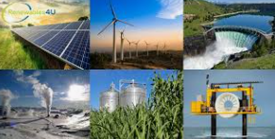
Geography
During the second half term, out geography topic will be ‘Where does our energy come from?’ We will explore the importance of energy, as well as renewable energy sources, before deciding what the best way to produce energy could be.

PSHE
During our PSHE lessons, we will be looking at dreams and goals. The children will have the opportunity to think about their personal goals and the steps needed to achieve them. In the second half term, our topic will be ‘Healthy Me’. We will discuss how we can take responsibility for our health and wellbeing as well as identifying healthy and unhealthy relationships.

Art
During the first half term, we will be expressing ideas through drawing. We will look at several street artists and learn techniques such as perspective and scaling up before planning and creating our own ‘street art’ to convey a message.

Design and Technology
During the second half term, our topic will be structures. The children will design and build small playground structures.

Computing
In Computing, we will continue our topic on web page creation. The children will evaluate what makes an effective webpage, before creating their own webpage whilst considering layout, copyright and hyperlinks.

RE
Our RE topic this half term is ‘Why is it better to be there in person?’ We will identify the common features and significance of both religious and non-religious gatherings, suggest reasons people might attend such events and explain the importance of place, people and practice in the context of gatherings. During the second half term, we will explore why there is suffering in the world, through looking at a range of different worldviews and beliefs.

Languages
During the term the children will continue to consolidate their learning from Year 5. We will focus on key phoneme sounds to help the children to pronounce words correctly. Children will revise words for sports and hobbies. As it’s pantomime season, we will use the story of ‘La Cinicienta’ (Cinderella) to learn how to form the simple future tense, both orally and in writing.

Music
The children will continue their weekly music lessons with Mr Pettifer. This half term, they will look at jazz, scat and improvisation. Next half term they will look at world music – Indonesian Gamelan.
Homework
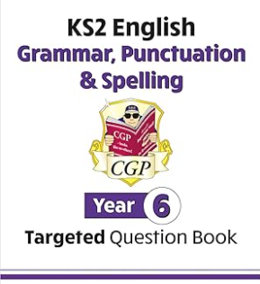 | Every week, children will be given both maths and grammar homework. Each child will have a CGP Rising Stars workbook. A page will be chosen to complete each week.  For maths, children will be given a homework sheet linked to their learning during the week.  Multiplication and division underpin many areas of maths, therefore it is essential that every child is fluent in their times tables. The children are expected to practise on TT Rockstars frequently.  https://play.ttrockstars.com/auth/school/student .

If you have any questions about your child’s learning, please do not hesitate to see us.

Thank you for your support,
Miss Plane, Mrs Bird and the Year 6 Team

