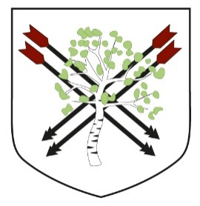
Birchwood Avenue Primary School
Headteacher: Miss Hall
www.birchwoodavenue.herts.sch.uk
________________________________________________________________________________________________________________________________________________________
Birchwood Avenue, Hatfield, Hertfordshire, AL10 0PS
01707 262503 admin@birchwoodavenue.herts.sch.uk @birchwoodavesch

Year 1
Autumn Newsletter

A very warm welcome to all our parents and carers of Year 1 children. We are really looking forward to having an exciting Autumn term with your children. Our learning value of the first half term will be ‘resilience’ where children will begin to understand the importance of continuing to try hard and put in effort, when things become challenging. We feel as a school that our values underpin our learning behaviour and this is reflected in our work.

Year One team
Class Teacher – Miss Khan
TA - Miss Melucci

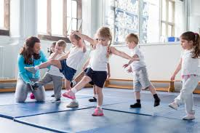
PE
Our PE days this term are Monday and Thursday. It would be helpful if all PE kits are sent to school at the beginning of each week. It is advised that children wear trainers for PE, which are much more supportive than plimsolls. In PE this term, the children will be developing their ball and team building skills, alongside dance, in which they will be exploring the dynamics of movement through gestures and travelling.

Phonics and English
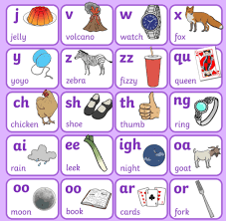
In phonics, the children will work in small groups each day with an adult. Children will learn new sounds, letter formation, and learn how to blend sounds together in order to read and spell words. They will build on this by learning how to write sentences using the correct punctuation. Children should be able to use their phonic knowledge to decode words and read accurately. They will develop their reading by using the sounds they learn to read books fluently and with more confidence. A Year 1 reader should also be able to talk about the events in books that they read.

In English, they use the skills that they develop in Phonics and apply them in their learning. The curriculum is text-led and the children will meet and explore a wide range of exciting books such as ‘Jasper’s Beanstalk’ and ‘Stanley’s stick’. A Year One writer should be able to compose sentences, use capital letters and full stops, and use joining words such as and. They should also be able to use spelling rules, for example, adding –ing or –ed to words.

Maths
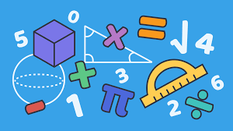
The focus for maths this term will be number and place value. The children will try to find patterns in groups of objects to help speedy counting before looking at numbers to 10 and 20 in more detail. They will regroup numbers, use them to solve problems and make comparisons. When they focus on place value to 20 after half term, they will begin to explore doubling and halving as well as odd and even numbers. By the end of Year 1, children should be able to read and write numbers to 100 and count in jumps of 2, 5 and 10. They will also be introduced to the concepts of multiplication, division and fractions. Additionally, they will develop their understanding of length, weight, capacity and time.

Science

This term the children will be finding out about everyday materials and their uses. They will explore the properties of a range of materials and use what they have discovered to complete experiments and test their ideas. In the second half of the term, the children will learn about autumn and winter and consider the changes that happen throughout the seasons, including thinking about the weather and hibernation.

History
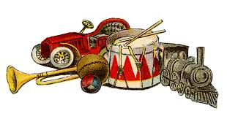
In History this term, the children will be learning about the past and how it connects to their own lives. They will explore timelines using photographs, talk about their own memories, and think about why these are special. The children will also learn about celebrations throughout the year and how birthdays are marked in different ways. They will compare childhood today with childhood in the past and will begin to think about how life might change in the future.


Geography

This term in Geography, the children will be developing their map and fieldwork skills through a range of practical activities. They will learn to identify features on an aerial photograph of the school and name the country and local area where they live. The children will create simple maps of their classroom and school grounds, using symbols to show direction and distance. They will also explore their playground, recording how they and their classmates feel about different areas through a survey, before using the results to design ideas for improving these spaces.

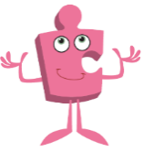
PSHE

During our PSHE lessons, the children will have the opportunity to think about and discuss ‘What it is to be me in my world’. We will think about our rights and responsibilities as members of the Year One class and consider the part we can play in making our class amazing.

Art and Design
This term the children will explore mark making and line. They will experiment with different materials through observational and collaborative pieces.

Design Technology
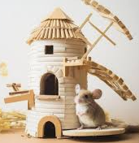
Inspired by the song, ‘Mouse in a windmill’, the children will design and construct a windmill for a client (mouse) to live in. We will explore various types of windmill, how they work and their key features. They will test and evaluate their finished product.

RE

In RE this term, the topic is Creation. The children will think about what they already know and believe about Creation before comparing stories from several different religions. They will present their own ideas using art and language and consider how creation stories help some people understand what God is like.

Computing
In the first half of the term, we will look at technology around us and how to use the mouse and keyboard accurately. We will think about our online identity and how to keep it safe. In the second half of the term we will be using computer programs to explore digital painting and get creative with our pictures.

Homework
The children will bring home a phonics reading book each week. This will be linked to the text they are reading in their phonics group. It is important to read with your children for up to 15 minutes a day. The reading record needs to be signed by an adult and brought into school every day. This will help them to develop a love of reading which they will carry with them throughout their lives.

Each Friday, children will be set a maths task to consolidate their maths learning in class. This will be sent home in a homework book and should be returned to school, completed, in their reading bag by Wednesday of the following week.

Alongside this will be phonics sounds for the children to practise, these will also go home on Fridays. Also on Fridays, some words from our Year 1 spelling list will come home for your child to practise. These are words that they should be able to spell by the end of the year and be able to use correctly in sentences. Children will be able to log on to Times Table Rock Stars to begin to practice counting in 2s and 10s.

If you have any questions or queries, we are always happy to help.

With best wishes,

Miss Khan and Miss Melucci

